Draft Jamaican Standard

Specification

for

**Labelling of goods — Part 1: General requirements**

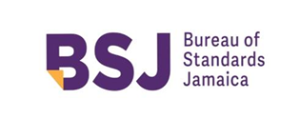

**BUREAU OF STANDARDS JAMAICA**

**COMMENT DEADLINE: 27 November 2019**

IMPORTANT NOTICE

Jamaican standards are subjected to periodic review. The next amendment will be sent without charge if you cut along the dotted line and return the self-addressed label. If we do not receive this label we have no record that you wish to be kept up-to-date. Our address:

Bureau of Standards Jamaica

6 Winchester Road

P.O. Box 113

Kingston 10

Jamaica W.I.

**---------------------------**(cut along the line)**-----------------------------------------------------------------------------------------**

JS 349: 2019

NAME OR DESIGNATION…………………………………….………………………………

ADDRESS……………………………………………………….………….……………………

……………………………………….…………………………………………………………….

……………………………………………………………………………………………………..

**JBS CERTIFICATION MARK PROGRAMME**

The general policies of the JBS Certification Mark Programme are as follows:

- The JBS provides certification services for manufacturers participating in the programme and licensed to use the gazetted JBS Certification Marks to indicate conformity with Jamaican Standards.

- Where feasible, programmes will be developed to meet special requirements of the submitter. Where applicable, certification may form the basis for acceptance by inspection authorities responsible for enforcement of regulations.

- In performing its functions in accordance with its policies, JBS will not assume or undertake any responsibility of the manufacturer or any other party.

Participants in the programme should note that in the event of failure to resolve an issue arising from interpretation of requirements, there is a formal appeal procedure.

Further information concerning the details of the JBS Certification Mark Programme may be obtained from the Bureau of Standards, 6 Winchester Road, Kingston 10.

**CERTIFICATION MARKS**

  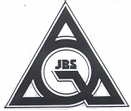

Product Certification Marks Plant Certification Mark

 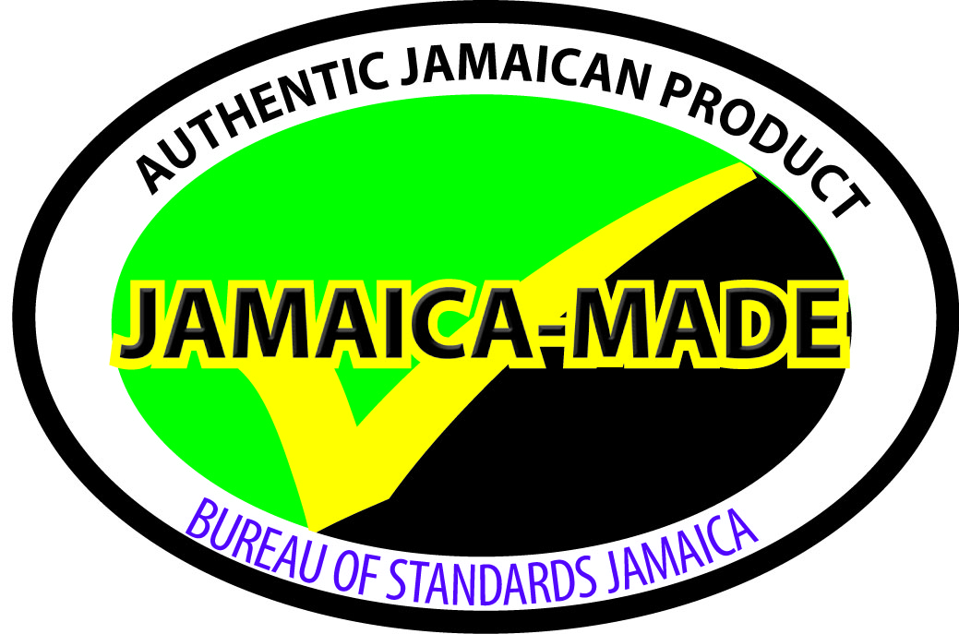

Certification of Agricultural Produce Jamaica-Made Mark

(CAP) Mark

**Draft Jamaican Standard**

**Specification**

**for**

**Labelling of goods — Part 1: General requirements**

Bureau of Standards Jamaica

6 Winchester Road

P.O. Box 113

Kingston 10

Jamaica W. I.

Tel: (876) 926 -3140-5, (876) 618 – 1534 or (876) 632-4275

Fax: (876) 929 -4736

E-mail: [info@bsj.org.jm](mailto:info@bsj.org.jm)

Website: [www.bsj.org.jm](http://www.bsj.org.jm)

Month 201x

© 201X Bureau of Standards Jamaica

**All rights reserved. Unless otherwise specified, no part of a Bureau of Standards Jamaica publication may be reproduced or utilized in any form or by any means, electronic or mechanical, including, photocopying microfilm or scanning, without permission in writing.**

ISBN XXXXXXXXXX

Declared by the Bureau of Standards Jamaica to be a standard specification pursuant to section 7 of the Standards Act, 1969.

First published Month 201x

This standard is being circulated in draft form for comments under the reference DJS 349: 2019.

Jamaican Standards establish requirements in relation to commodities, processes and practices, but do not purport to include all the necessary provisions of a contract.

The attention of those using this specification is called to the necessity of complying with any relevant legislation.

Amendments

|  |  |  |  |
| --- | --- | --- | --- |
| No. | Date of Issue | Remarks | Entered by and date |
|  |  |  |  |

**Contents**

**Page**

National foreword iv

Committee representation v

Acknowledgement v

1 Scope 1

2 Terms and definitions 1

3 Requirements 2

4 Product specific supplementary specifications 4

Tables

1 Minimum type size 3

**National foreword**

This standard replaces JS 1 Part 1: 1992 Jamaican Standard Specification for the *Labelling commodities Part 1: General principles.*

This standard is intended to:

1. assist the purchaser or consumer to make informed decisions based on an understanding of the nature, quality or use of the goods; and
2. enable the manufacturer or retailer to describe the goods at the point of sale in a truthful, informative and non-deceptive manner.

In formulating this standard considerable assistance was derived from the following:

* *CRS 55-1: 2016 Labelling of goods – Part 1: General Requirements*
* Trinidad and Tobago Bureau of Standards. TTS 76: Part 1: 2006 *Requirements for Labelling - Part 1: General Principles;*
* Barbados National Standards Institute. BNS 5: Part 1:1974 *Labelling of Commodities (General)*;
* Bureau of Standards Jamaica. JS 1: Part 1:1992 *Labelling of Commodities Part 20: General Principles*;
* U.S. Food and Drug Administration. A Food Labeling Guide - January 2013.

Where reference is made to informative and normative annexes the following definitions should be noted:

* Informative Annex – gives additional information intended to assist in the understanding or use of the document. They do not contain requirements.
* Normative Annex – gives provisions additional to those in the body of a document. They contain requirements.

This standard is intended to be compulsory.

iv

**Committee Representation**

The preparation of this standard for the Standards Council, established under the Standards Act, 1969 was carried out under the supervision of the Labelling Technical Committee, which at the time comprised the following members:

**Acknowledgment**  
Acknowledgement is made to the CARICOM Regional Organisation for Standards & Quality to reproduce material from — CRS 55-1: 2016 *Labelling of goods – Part 1: General Requirements*.

v

**DJS 349: 2019**

**Draft Jamaican Standard Specification for Labelling of goods — Part 1: General requirements**

1. **Scope**

This standard establishes general labelling requirements for goods. It is applicable to all goods which are sold, distributed or used, except those for which specific requirements have been elsewhere prescribed in CARICOM Regional Standards, or national regulations.

1. **Terms and definitions**

For the purposes of this document, the following terms and definitions shall apply:

#### 2.1

#### competent authority

a Minister, Ministry, any named government agency, or agencies assigned, separately or jointly, the different areas of legal responsibility associated with the labelling of goods

#### 2.2

#### country of origin

1. country where the goods were wholly manufactured; or
2. in cases where the composition and or quality of the goods was changed to a significant extent elsewhere (other than by packaging), the last country where such significant change occurred

NOTE A significant change in the product refers to where there is a change in the product that has resulted in a change of the Harmonized Commodity Description and Coding System (HS Code), or where there is no change in the HS Code, but the product has gone through a significant process.

#### 2.3

#### defect

a characteristic causing the non-fulfilment of specific requirements

#### 2.4

#### defective

containing one, or more defects

#### 2.5

#### goods

any commodity, article, product or thing, which is the subject of trade or commerce

#### 2.6

#### imperfect

not perfect; faulty or incomplete

#### 2.7

#### label

any tag, ticket, brand, mark, pictorial or other descriptive matter, written, printed, stenciled, marked, embossed, impressed on, accompanying, attached or permanently fastened to a container

#### 2.8

#### labelling

includes the label and any written, printed, stenciled, marked and or embossed information / instructions relating to and accompanying the good

#### 2.9

#### legible

the written or printed matter that can be read without difficulty under the conditions in which the label is normally displayed to a consumer

#### 2.10

#### package

any container, wrapper, confining band, or card in which the good is intended for sale to the retail purchaser or distribution to the public

#### 2.11

#### pre-owned

having had a previous owner, regardless of whether or not it has been used

#### 2.12

#### principal display panel main display panel

that part of the package which is most prominently displayed, shown or examined under customary conditions of display for retail sale

#### 2.13

#### reconditioned refurbished

goods which have been overhauled, repaired, refitted, or have undergone a similar process to be made reusable

#### 2.14

#### seconds

good which does not fully satisfy the specific requirements for the particular good, but which still fulfils intended usage requirements

NOTE 1 The ‘specific requirements’ referred to are those specified by the manufacturer and may be a company specification, industry standard, foreign, national or international standard

NOTE 2 The classification of goods as “seconds” is greatly dependent on the manufacturer’s own product specification or standard

#### 2.15

#### unit of measurement

any unit in the SI system of units or the Imperial System of units or any other unit prescribed by legal requirement for use in trade, or commonly used in trade, science, the arts, or other occupations to measure the properties of a good

#### 2.16

#### used

second-hand, not new, having had a previous owner

#### 2.17

#### weight

a system of units for expressing heaviness or mass (g / kg)

1. **Requirements**
   1. **General**

A label affixed to, or marked on any goods, or its external packing or referring to any goods, shall conform to the following requirements:

**DJS 349: 2019**

1. It shall provide a description of the goods and adequate information to a potential purchaser enabling the purchaser, or consumer to select the goods best suited to their needs. This information shall include the weight, net weight, volume, net volume, measurement, specification, or size, as applicable, and shall give an accurate description of components of the goods as is necessary.
2. It shall provide a purchaser or consumer with appropriate operating and safety instructions, and with information on care, maintenance and precautions in use, where:
   1. there is a risk to the health and safety of a consumer;

EXAMPLE The inclusion of health warnings or allergy risks.

* 1. any significant deterioration of the quality, performance or life durability which may result, if the goods are not properly stored; and
  2. the good is handled, transported, used, installed, cared for, maintained or repaired, the appropriate hazard symbol and instructions for use shall be provided on the label, on the package or on the good.

1. The name and identifiable address, the principal place of business or registered office of the manufacturer, agent, distributor, seller, re-filler, packer, importer or organization responsible for the product and the name of the country of origin. It shall be preceded by the words “manufactured by ....”, “packed by......”, “distributed by....”, “imported by.....”, as applicable, and the following words as appropriate:
   1. “made in (name of territory)”;
   2. “product of (name of territory)”;
   3. “packaged in (name of territory)”;
   4. “manufactured in (name of territory)”; and
   5. “assembled in (name of territory)”.

The label shall be legible and durable up to the point-of-sale to the ultimate consumer, and where appropriate, during normal working life and use. For legibility, the information appearing on a label shall be in a minimum type size in accordance with 3.1. (d).

1. The minimum type size shall be the smallest type size that is permitted, based on space available for labelling. The height of the type shall be determined by measuring the height of the lower case ‘o’ or its equivalent when mixed upper and lower case letters are used, or the height of the upper case letters when only upper case letters are used. Minimum type sizes shall be as outlined in Table 1 below:

**Table 1 — Minimum type size**

|  |  |
| --- | --- |
| **Minimum type size** | **Area of principal display panel** |
| 1.6 mm (1/16 in) | 32 cm2 (5 in2) or less |
| 3.2 mm (1/8 in) | more than 32 cm2 (5 in2) |

1. The label shall not be false**,** misleading or deceptive.
2. The label shall provide information regarding any specific dangers which might be related to the use of the good and shall provide first aid instructions where necessary.

**DJS 349: 2019**

1. The label shall not contain any information by words, pictorial or other devices which refer to, or are suggestive, either directly or indirectly, of another good with which such a product might be confused. The label should not lead the purchaser, or consumer to suppose that the good is connected with such other products.
2. All pre-packaged goods shall be labelled in compliance with this standard.
   1. **Prevention of deception**

A claim shall not be made on the label unless it can be substantiated. A good shall not be described, or presented in a manner that is false, misleading or deceptive to create an erroneous impression regarding its character in any respect.

* 1. **Language to be used on labels of pre-packaged goods**

The wording on labels for use in the Caribbean Community shall be in the official language or languages of the country in which the goods are sold.

* 1. **Responsibility for labelling of goods**

It is the responsibility of any person who manufactures, sells or distributes any goods to ensure that they are labelled as required by this standard.

#### 3.4.1 Labelling of used, defective, seconds, irregular and imperfect goods

All goods which are used goods, defective, seconds/irregular or imperfect shall be clearly and conspicuously labelled with the words 'USED', ‘DEFECTIVE’, 'SECONDS', ‘IRREGULAR’, ‘PRE-OWNED’, ‘RECONDITIONED’, ‘REFURBISHED’ or ‘IMPERFECT as appropriate; as long as the product remains marketable and safe.

1. **Product specific supplementary specifications**

Product specific supplementary specifications for particular goods or groups of goods, as well as the labelling clauses in product standards, shall be read in conjunction with this standard.

**Standards Council**

The Standards Council (also referred to as the Council) is the controlling body of the Bureau of Standards Jamaica (also referred to as the Bureau) and is responsible for the policy and general administration of the Bureau.

The Council is appointed by the Minister in the manner provided for in the Standards Act, 1969. Using its powers in the Standards Act, the Council appoints committees for specified purposes.

The Standards Act, 1969 sets out the duties of the Council and the steps to be followed for the formulation of a standard.

**Preparation of standards documents**

The following is an outline of the procedure which must be followed in the preparation of documents:

1. The preparation of standards documents is undertaken upon the Standard Council’s authorization. This may arise out of representation from national organizations or existing Bureau of Standards’ Committees of Bureau staff. If the project is approved it is referred to the appropriate sectional committee or if none exists a new committee is formed, or the project is allotted to the Bureau’s staff.

2. If necessary, when the final draft of a standard is ready, the Council authorizes an approach to the Minister in order to obtain the formal concurrence of any other Minister who may be responsible for any area which the standard may affect.

3. The draft document is made available to the general public for comments. All interested parties, by means of a notice in the Press, are invited to comment. In addition, copies are forwarded to those known, interested in the subject.

4. The Committee considers all the comments received and recommends a final document to the Standards Council.

5. The Standards Council recommends the document to the Minister for publication.

6. The Minister approves the recommendation of the Standards Council.

7. The declaration of the standard is gazetted and copies placed on sale.

8. On the recommendation of the Standards Council the Minister may declare a standard compulsory.

9. Amendments to and revisions of standards normally require the same procedure as is applied to the preparation of the

original standard.

**Overseas standards documents**

The Bureau of Standards Jamaica maintains a reference library which includes the standards of many overseas standards organizations. These standards can be inspected upon request.

The Bureau can supply, on demand, copies of standards produced by some national standards bodies and is the agency for the sale of standards produced by International Organization for Standardization (ISO) members.

Application to use the reference library and to purchase Jamaican and other standards documents should be addressed to:

Bureau of Standards Jamaica

6 Winchester Road

P.O. Box 113,

Kingston 10

JAMAICA, W. I.